Create a Brownian motion process for stock returns using Monte Carlo Simulations in Excel

1. The inputs are the annualized *m*, *s*, and *S*0 that must be calibrated to an index

(CSI 500). Because of the choice of discretization), one should use

simple historical returns (as opposed to log),

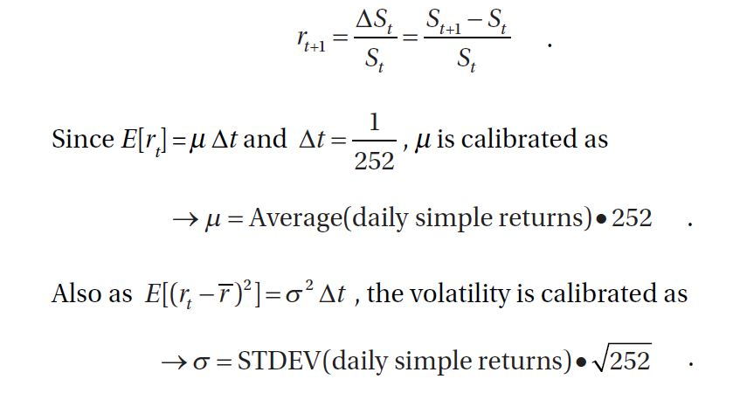

*S*0 will be the last available price for the index.

2. Use this to generate 65,000 paths for 21 time steps.

3. *Calibration and Generation Check*. For the 21*st* day return, the Mean, Stdev,

and Kurt should be close to the inputs, with Kurt = 3 for Brownian Motion. The

21*st* day return will be

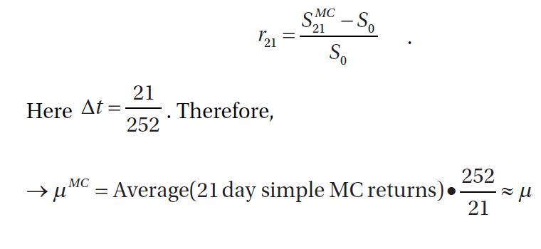

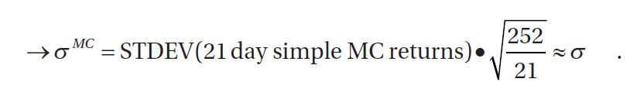

The level of convergence between the simulated *mMC* and *sMC* and the input ones is determined by the quality of the random numbers and the number of paths generated. A detailed discussion on MC simulations and convergence can be found in Glasserman [2003].

4. For the 21*st* MC return, one can calculate the 99% and 99.9% VaR and CVar.